***Before you begin***

Use the [Azure DevOps Demo Generator](https://azuredevopsdemogenerator.azurewebsites.net/?name=keyvault) to provision Terraform project on your Azure DevOps organization.

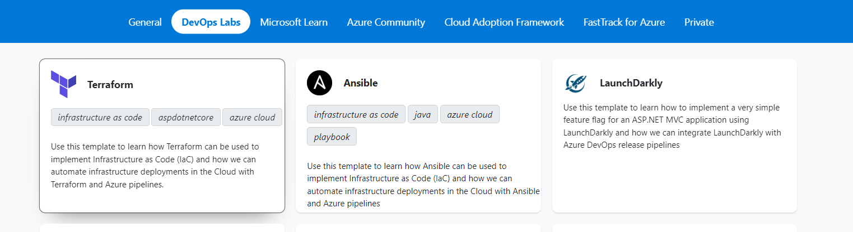

Go to the project at dev.azure.com and build the pipeline to generate artifacts.

Release Pipeline Steps to deploy using Terraform

Goto Pipelines -> releases and create a new release pipeline say “release piepeline”.

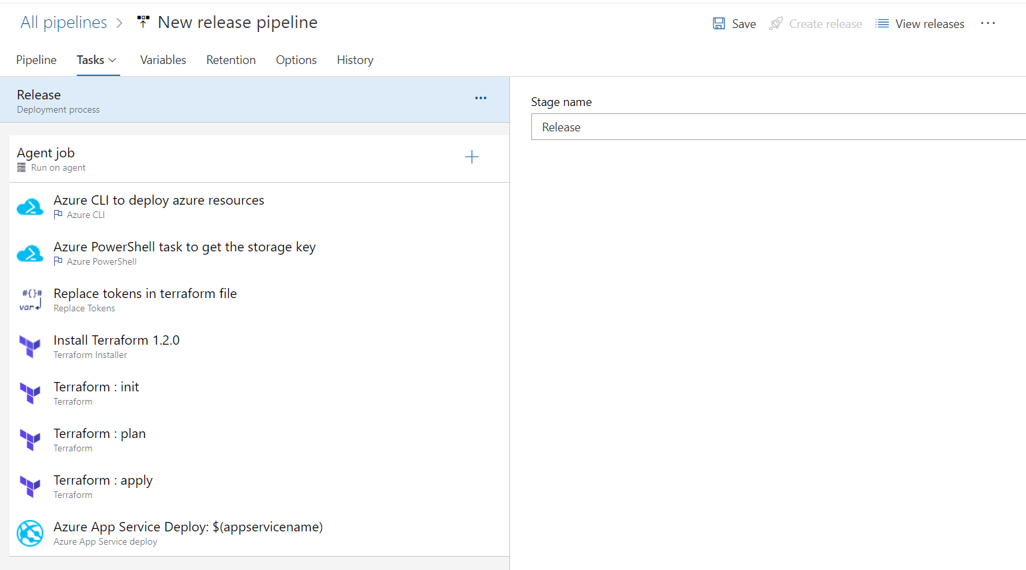

Task-1

Install Terraform 1.2.0 or latest version.

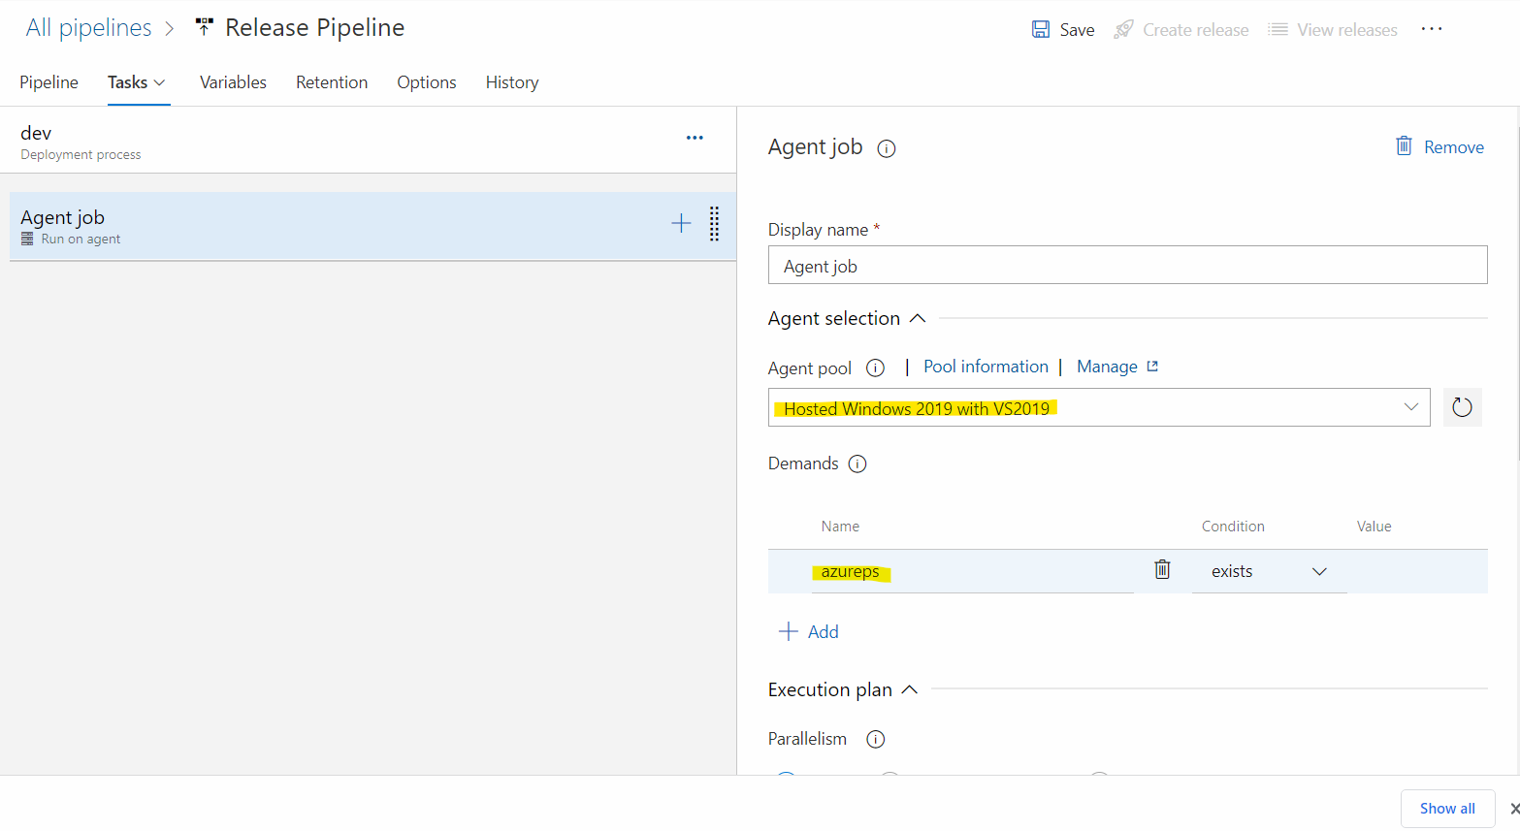

Task-2

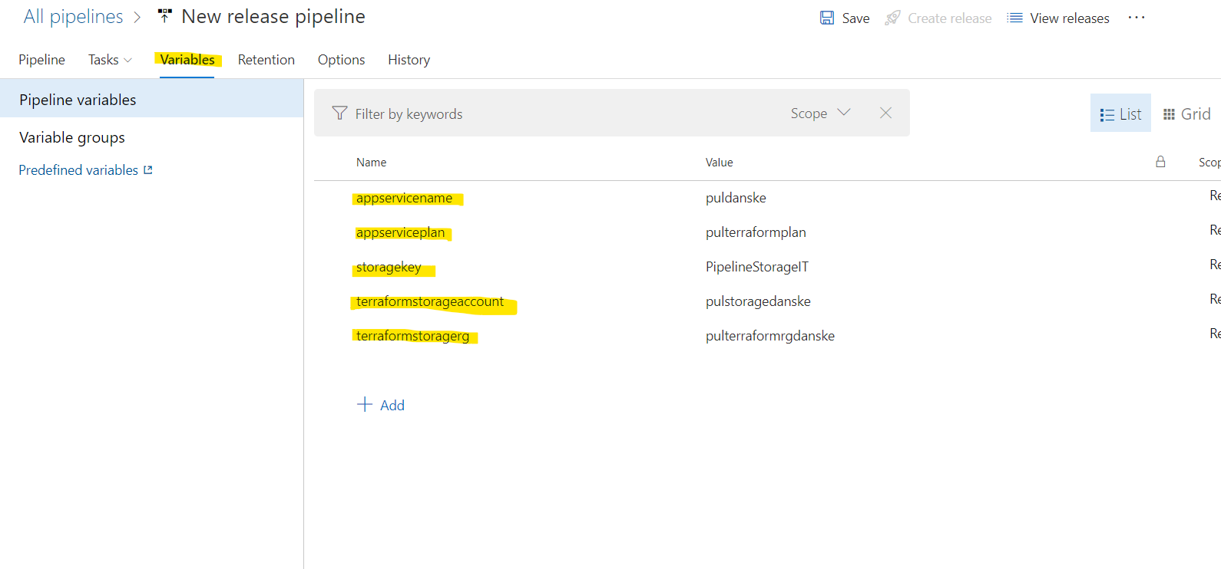

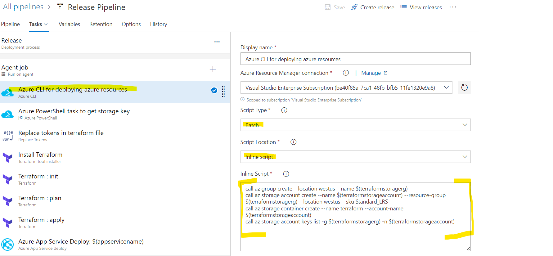

Inline Script

# this will create Azure resource group

call az group create --location westus --name $(terraformstoragerg)

call az storage account create --name $(terraformstorageaccount) --resource-group $(terraformstoragerg) --location westus --sku Standard_LRS

call az storage container create --name terraform --account-name $(terraformstorageaccount)

call az storage account keys list -g $(terraformstoragerg) -n $(terraformstorageaccount)

Task-3

Note: If error out then modify the task version to 3.*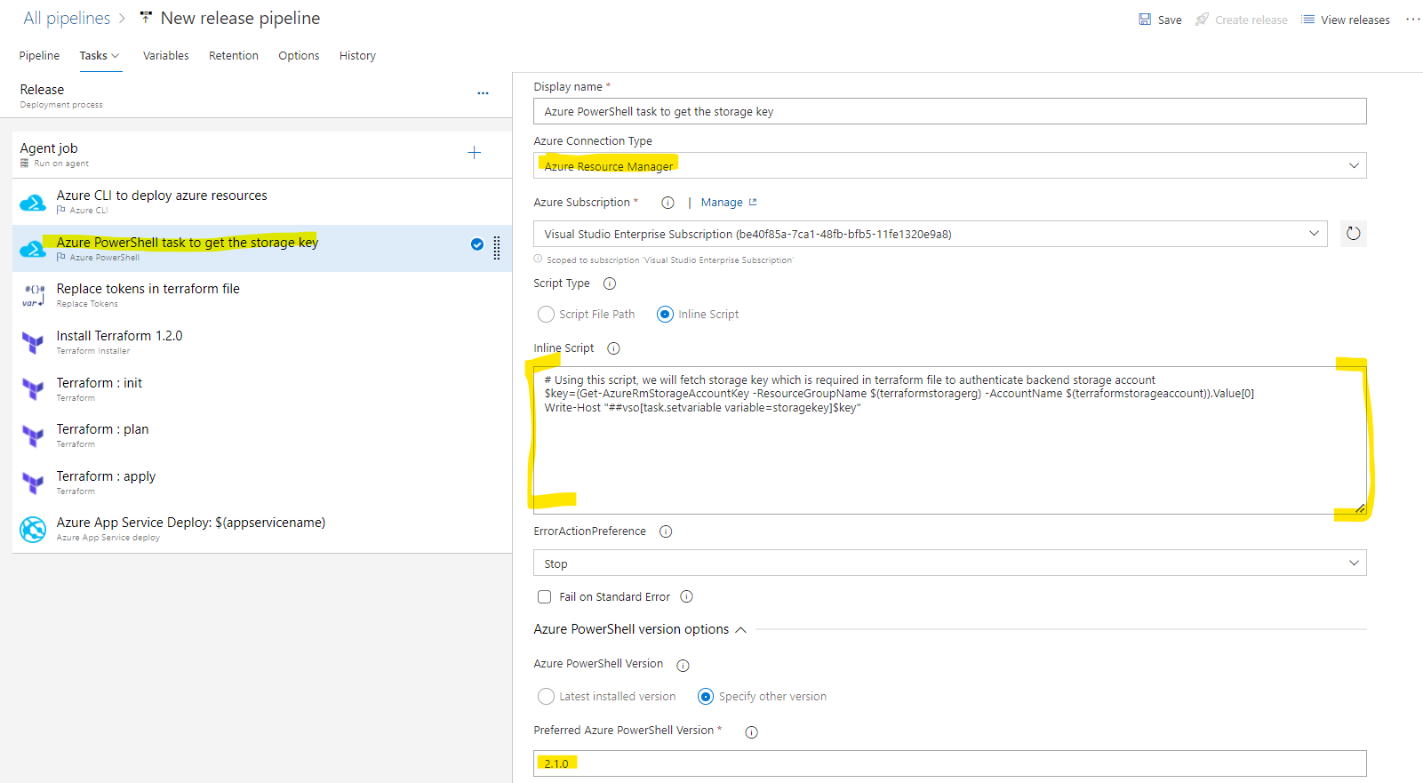

Inline Script

# Using this script, we will fetch storage key which is required in terraform file to authenticate backend storage account

$key=(Get-AzureRmStorageAccountKey -ResourceGroupName $(terraformstoragerg) -AccountName $(terraformstorageaccount)).Value[0]

Write-Host "##vso[task.setvariable variable=storagekey]$key"

Task-4

Note: download “replace token” from marketplace if not available

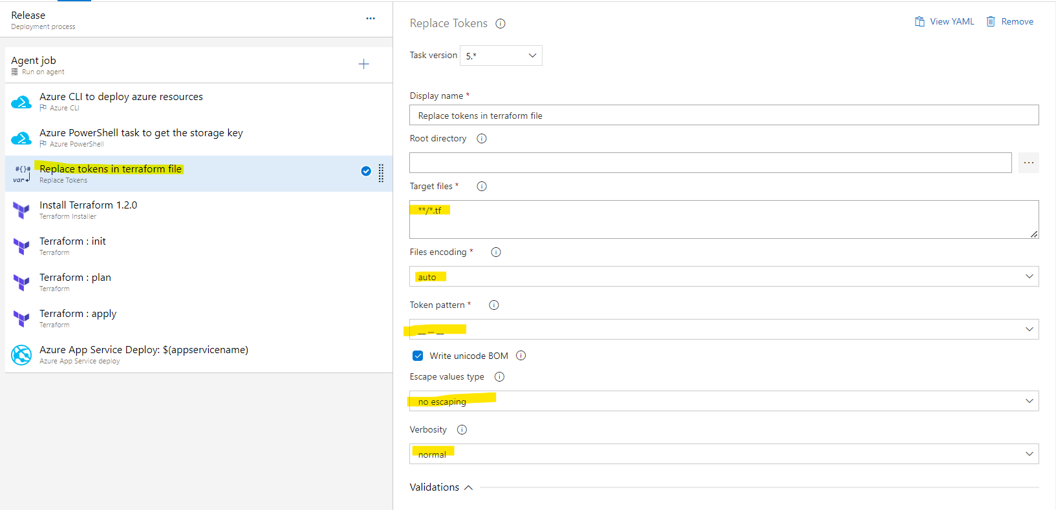

Task-5

Note: download “terraform installer” from marketplace if not available.

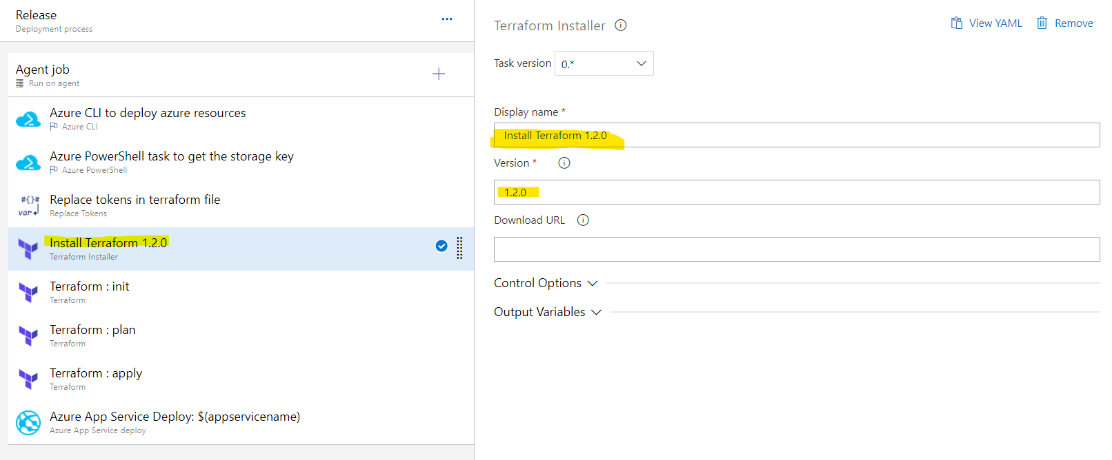

Task-6

Note: download “terraform” from marketplace if not available.

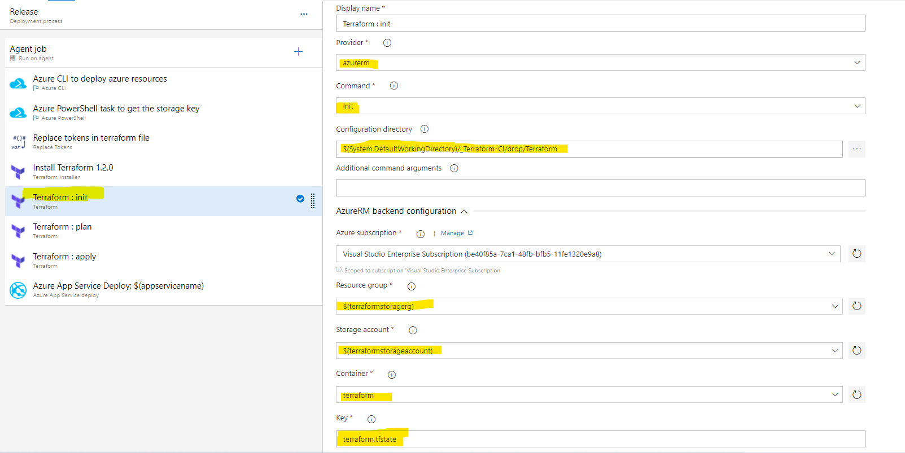

Configuration directory

$(System.DefaultWorkingDirectory)/_Terraform-CI/drop/Terraform

Task-7

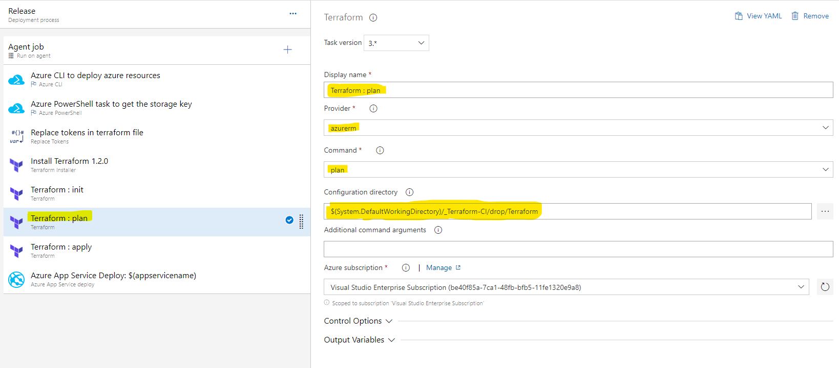

Task-8

“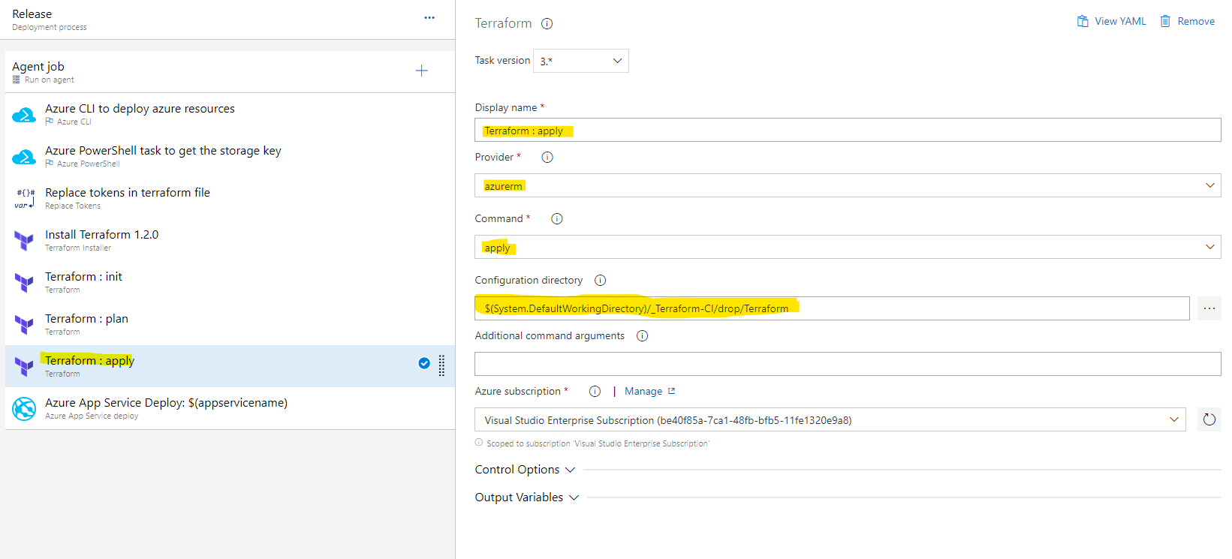

* Goto webapp and verify the application is deployed successfully.
* Enable continuous integration and continuous deployment and modify source code say “/src/PartsUnlimitedWebsite/Views/Home/Index.cshtml” to auto-trigger the pipeline.
* Also, you can enable “pre-deployment approvals” and “pre-deployment gates” and verify.

Task-9

